Module 10

10.2 Assignment
Course: CSD325 – 340A
Prepared By: Mirach Erkol
Date of Report: 12/7/25

Mikey5007/csd-325: csd-325

10.2 Assignment #1: Application Running with tasks added
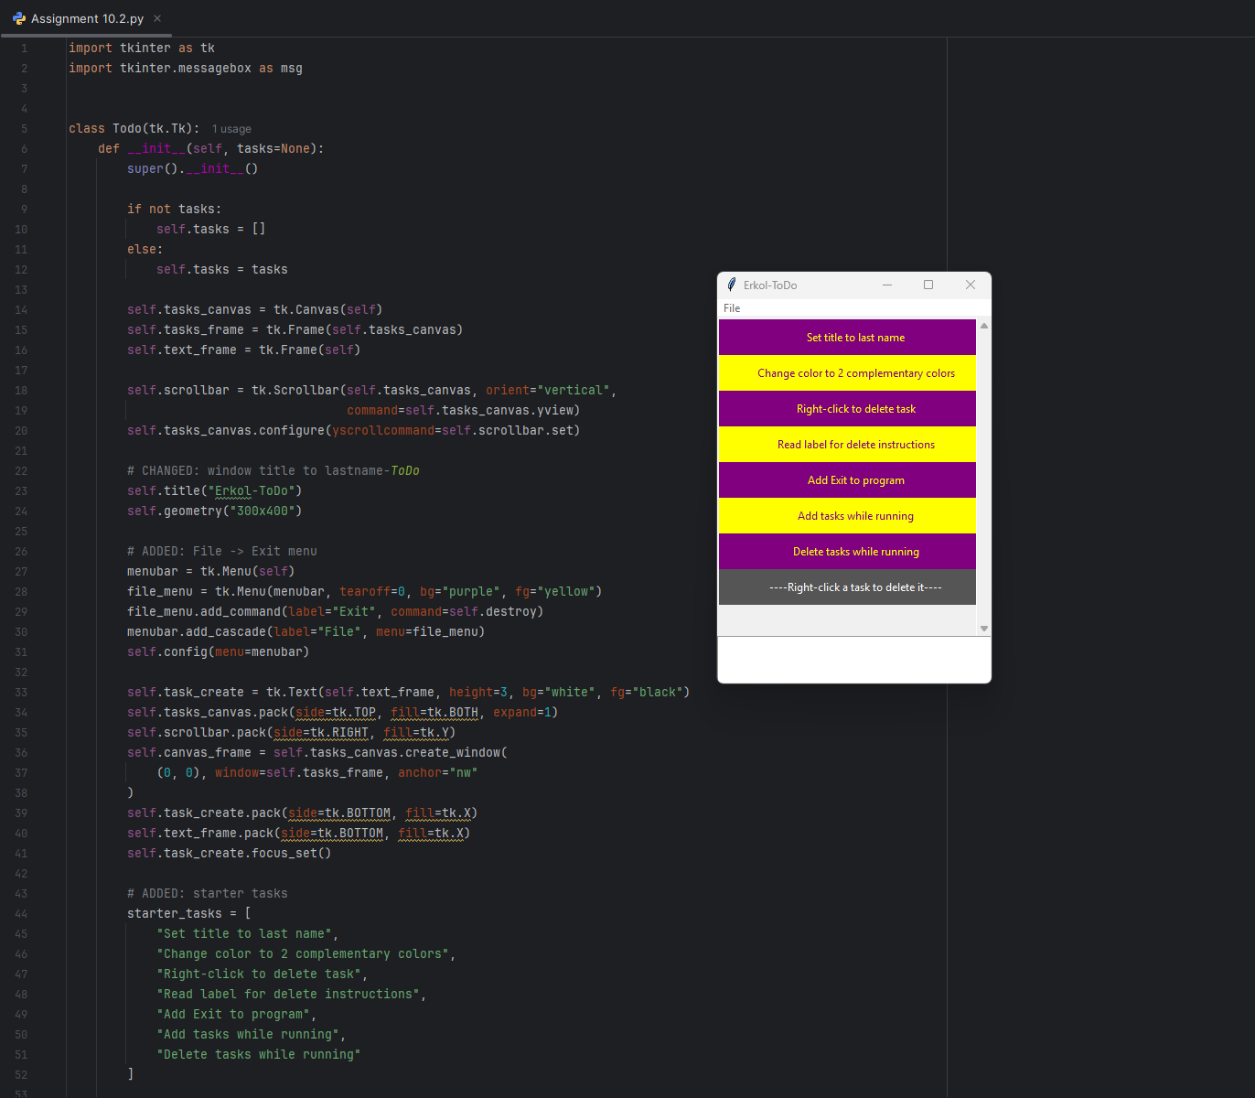

10.2 Assignment #2: Tasks Deleted from To-Do List
